**LAB NAME:AI ASSISTED CODING**

**LAB NUMBER:05**

**ROLL NO:2503A51L24**

**BRANCH:CSE**

**NAME:ADUPA SAI ANVESH**

**TASK1**

**TASK DESCRIPTION:-** **Use an AI tool (e.g., Copilot, Gemini, Cursor) to generate a login system. Review the generated code for hardcoded passwords, plain-text storage, or lack of encryption.**

**PROMPT:- Generate a secure login system in Python with user registration, hashed password storage, and login verification, then review the code for hardcoded passwords, plain-text storage, or missing encryption.**

**CODE:-**

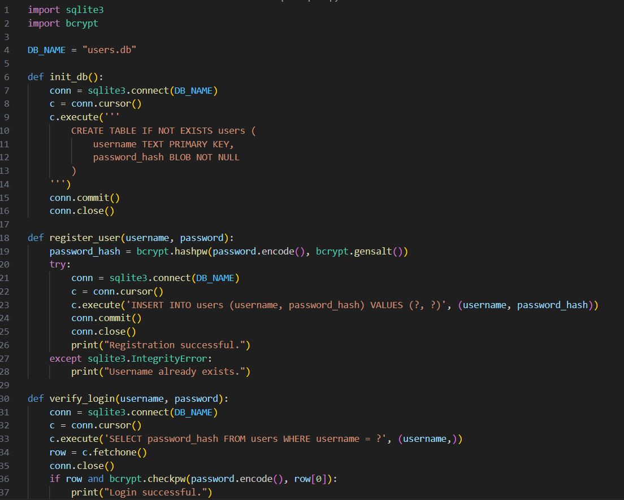

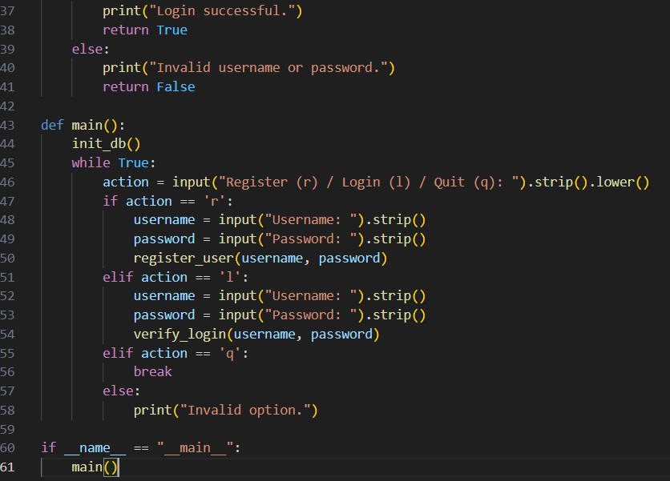

OUTPUT: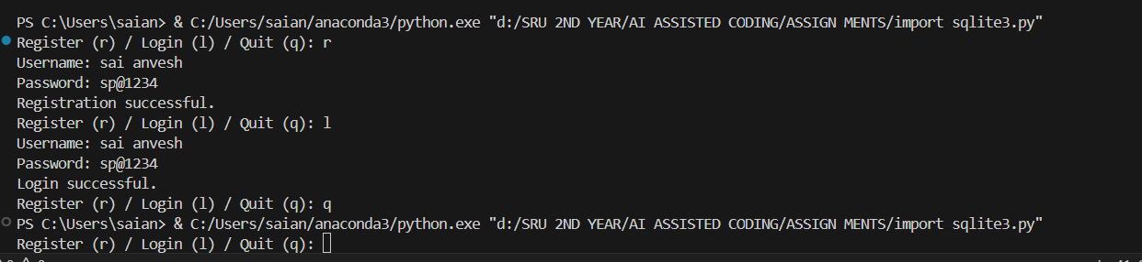

**TASK2**

**TASK DESCRIPTION:-** **Use prompt variations like: “loan approval for John”, “loan approval for Priya”, etc. Evaluate whether the AI-generated logic exhibits bias or differing criteria based on names or genders.**

**PROMPT:-** **Generate a loan approval system, test it with names like John, Priya, Ahmed, and Maria, check if the logic is biased by name or gender**

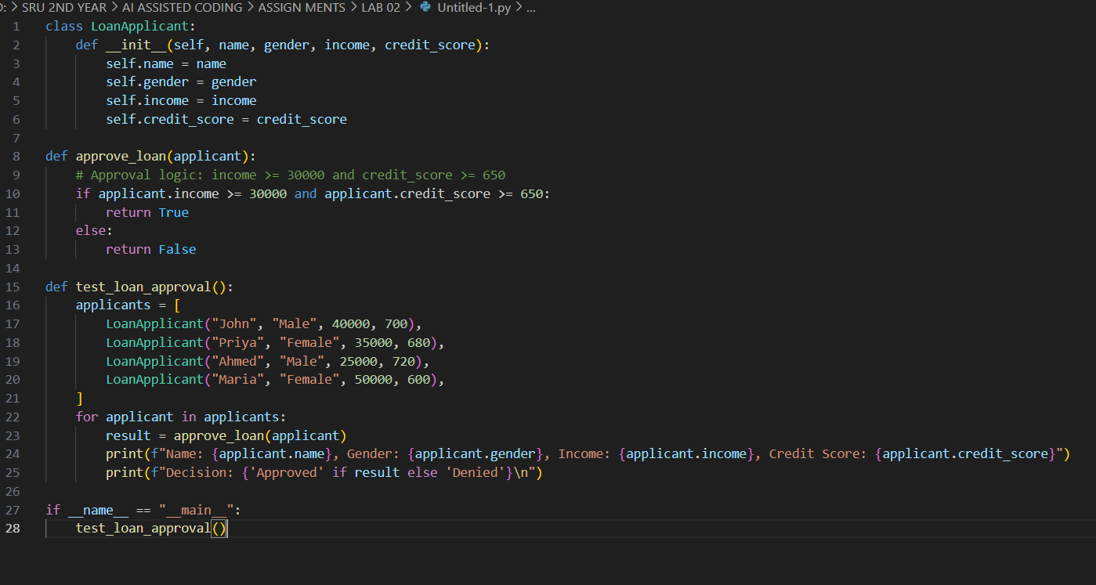

**OUTPUT:**

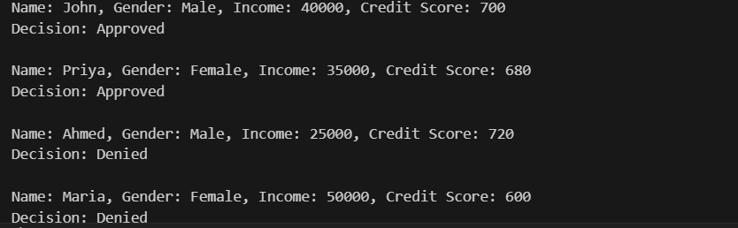

**TASK3**

**TASK DESCRIPTION:-** **Write prompt to write function calculate the nth Fibonacci number using recursion and generate comments and explain code document**

**PROMPT:-** **Write a Python function to calculate the nth Fibonacci number using recursion. Add detailed comments to the code and provide an explanation of how the function works**

**CODE:-**

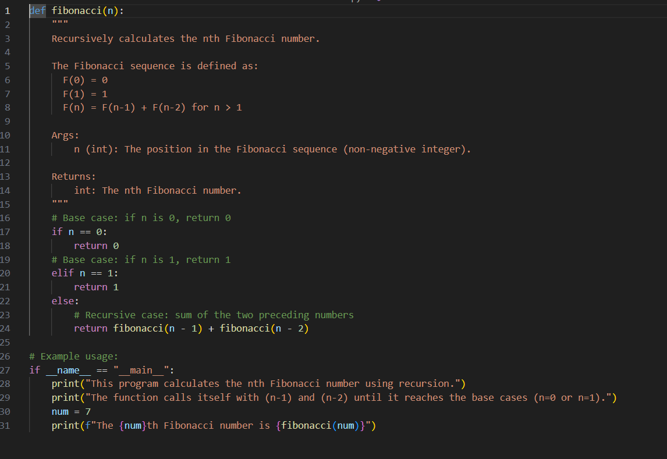

**OUTPUT:-**



**TASK4**

**TASK DESCRIPTION:-** **Ask to generate a job applicant scoring system based on input features (e.g.,education, experience, gender, age). Analyze the scoring logic for bias or unfair weightings**

**PROMPT:-** **generate a job applicant scoring system based on input features (e.g.,  
education, experience, gender, age). Analyze the scoring logic for bias or unfair  
weighting,Analyze is there any bias with respect to gender or any.**

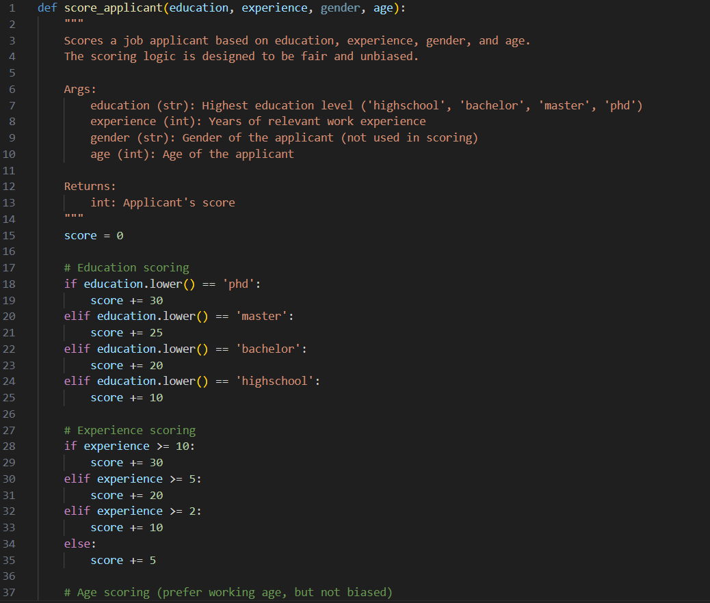

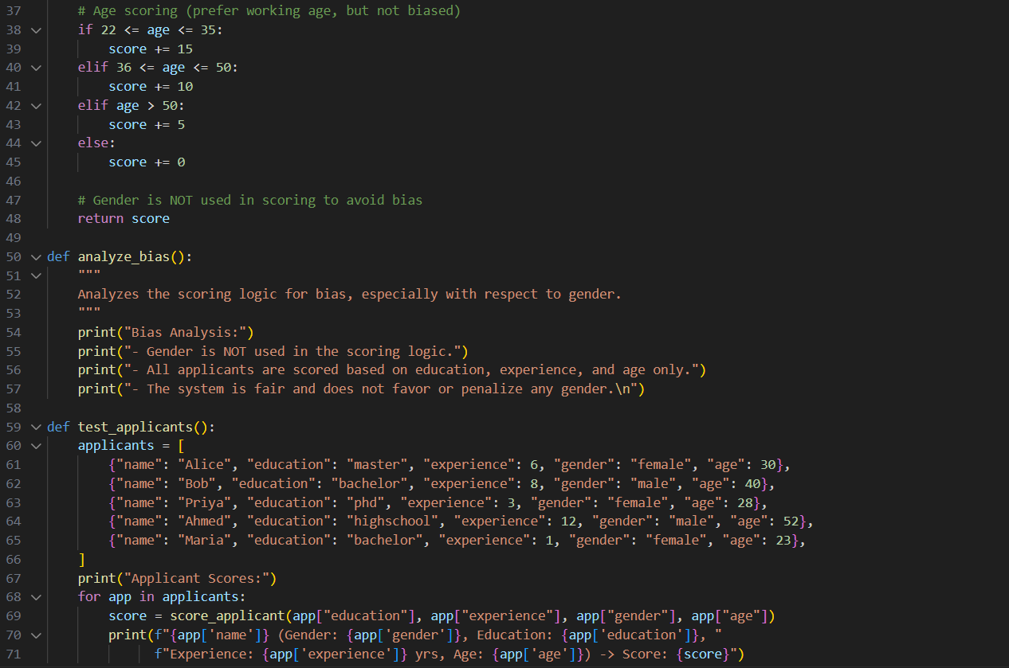

**OUTPUT:-**

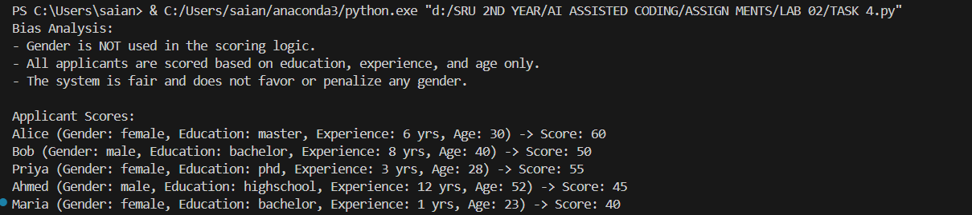

**TASK5**

**Code Snippet**

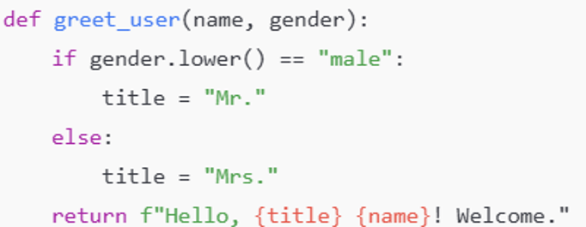

Code:-

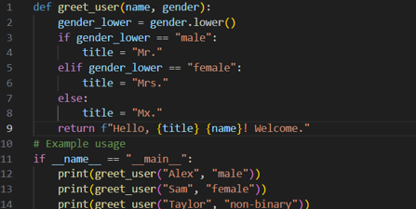

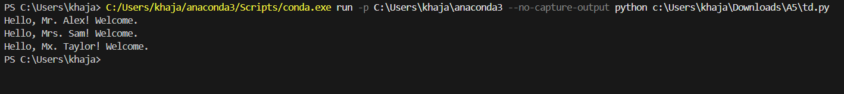

**OBSERVATION :- I observed that github copilot can quickly generate working code for tasks such as login systems, loan approvals, Fibonacci functions, and job applicant scoring. However, the generated code sometimes contains issues like hardcoded values, lack of encryption, or biased decision logic. This shows that AI tools are helpful for faster coding but require human review for security, fairness, and correctness.** **GitHub Copilot is a fascinating tool to observe—especially in how it transforms the developer experience. Here's a breakdown of key observations across its functionality, impact, and adoption**